1. Write a query to display customer list by the first name in descending order.

2. Write a query to display the first name, last name, and city of the customers. It sorts the customer list by the city first and then by the first name.

3. Write a query to returns the top three most expensive products.

4. Write a query to finds the products whose list price is greater than 300 and model year is 2018.

5. Write a query to finds products whose list price is greater than 3,000 or model year is 2018. Any product that meets one of these conditions is included in the result set.

6. Write a query to find the products whose list prices are between 1,899 and 1,999.99.

7.Write a query uses the [IN](http://www.sqlservertutorial.net/sql-server-basics/sql-server-in/) operator to find products whose list price is 299.99 or 466.99 or 489.99.

8. Write a query to the customers where the first character in the last name is the letter in the range A through C:

9. Write a query using  NOT LIKE operator to find customers where the first character in the first name is not the letter A:

10.Write a query to find the distinct phone numbers of the customers.

11.Write a query to find products whose list price is greater than 3000 or model is 2018.

12.Write a query to find products whose name contains the string **Cruiser.**

13. Write a query to find the products whose list price is one of the following values: 89.99, 109.99, and 159.99

14.Write a query to display full_name by merging first_name and last_name columns.

15.Write a query to fetch records from products table and categories table on the basis of category_id using INNER JOIN.

16.Write a query to fetch records from staff table and orders table on the basis of staff_id using LEFT JOIN

17.Write a query to get below result from orders table using GROUP BY.

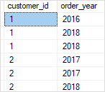

18. Write a query to get below result from orders table using GROUP BY.

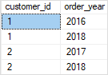

19. Write a query to get the number of customers in every city using GROUP BY.

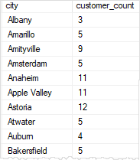

20. Write a query to get the number of customers by state and city using

GROUP BY.

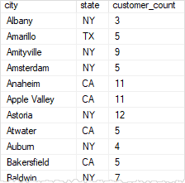

21. Write a stored procedure to insert record into customers table using parameterized stored procedure. (declare parameters for all fields except auto incremented field)

22.Write a stored procedure to delete record from customers table using parameterized stored procedure by taking customerid as input.

23.Write a stored procedure to update record for customers table using parameterized stored procedure. (declare parameters for all fields except auto incremented field)